# CSP554—Big Data Technologies

## Assignment #4

Generated Magic Number ;

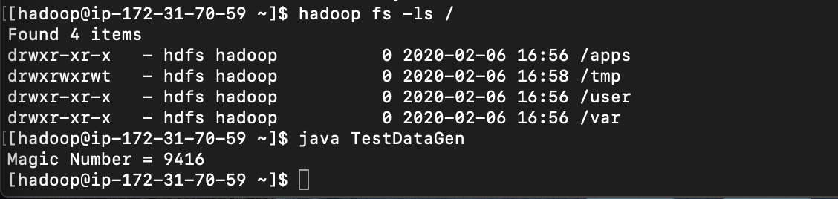

**Exercise 1)**

Create a Hive database called “MyDb”.



changing the default database via a hive command



**Execute a Hive command of ‘DESCRIBE FORMATTED MyDb.foodratings;’ and capture its output as one of the results of this exercise.**

**FOODRATINGS TABLE:**

CREATE TABLE IF NOT EXISTS MyDb.foodratings(name String COMMENT 'FoodName', food1 int COMMENT 'FOOD1Rating', food2 int COMMENT 'Food2Rating',food3 int COMMENT 'food3Rating', food4 int COMMENT 'food4Rating',id int COMMENT 'Restuarent_ID')COMMENT 'RatingsTable' ROW FORMAT DELIMITED FIELDS TERMINATED BY','LINES TERMINATED BY '\n' STORED AS TEXTFILE;



**Execute a Hive command of ‘DESCRIBE FORMATTED MyDb.foodplaces’ and capture its output as another of the results of this exercise.**

**FOODPLACES TABLE:**

CREATE TABLE IF NOT EXISTS MyDb.foodplaces(id INT,place STRING ) ROW FORMAT DELIMITED FIELDS TERMINATED BY','LINES TERMINATED BY '\n' STORED AS TEXTFILE;

**Exercise 2)**

**Load the foodratings<.magic number>.txt file created using TestDataGen from your local file system into the foodratings table.**

LOAD DATA LOCAL INPATH './foodratings9416.txt' INTO table foodratings; 

**Execute a hive command to output the min, max and average of the values of the food3 column of the foodratings table. This should be one hive command, not three separate ones.**

Magic Number : 9416

select min(food3), max(food3),avg(food3) from foodratings;

**Exercise 3)**

**Execute a hive command to output the min, max and average of the values of the food1 column grouped by the first column ‘name’. This should be one hive command, not three separate ones.**

Magic Number : 9416

select name, min(food1),max(food1),avg(food1) from foodratings GROUP BY name;

**Exercise 4)**

**In MyDb create a partitioned table called ‘foodratingspart’**

create table foodstringspart (food1 int, food2 int, food3 int, food4 int, id int)PARTITIONED BY(name STRING) ROW FORMAT DELIMITED FIELDS TERMINATED BY ',' STORED AS TEXTFILE;

**Exercise 5)**

**Assume that the number of food critics is relatively small, say less than 10 and the number places to eat is very large, say more than 10,000. In a few short sentences explain why using the (critic) name is a good choice for a partition field while using the place id is not.**

Partition table in hive works as the partition column data/value is not stored in the actual data file in warehouse instead it is stored in the hive meta store.

**Disadvantage of choosing place id as partition column:**

Too may small directories which may cause overhead in HDFS.

**Advantages of using name:**

* Number of directories will be fixed. It all depends how the query will be formed for execution.
* Also, creating partition does not guarantee faster execution. The search results will be returned faster for partitions where data volume is less compared to the partitions where data volume is high

**Exercise 6)**

**Configure Hive to allow dynamic partition creation as described in the lecture. Now, use a hive command to copy from MyDB.foodratings into MyDB.foodratingspart to create a partitioned table from a non-partitioned one.**

INSERT OVERWRITE TABLE foodstringspart PARTITION (name) SELECT food1, food2, food3, food4, id, name FROM foodratings;

**Execute a hive command to output the min, max and average of the values of the food2 column of MyDB.foodratingspart where the food critic ‘name’ is either Mel or Jill**.

select min(food2), max(food2), avg(food2) FROM foodstringspart where name='Mel' OR name='Jill';

**Exercise 7) 2 points**

**Load the foodplaces<.magic number>.txt file created using TestDataGen from your local file system into the foodplaces table.**

LOAD DATA LOCAL INPATH './foodplaces9416.txt' INTO table foodplaces;



**Use a join operation between the two tables (foodratings and foodplaces) to provide the average rating for field food4 for the restaurant ‘Soup Bowl’**

Select place, avg(foodratings.food4) FROM foodplaces JOIN foodratings ON(foodplaces.id =foodratings.id) WHERE PLACE= 'Soup Bowl' GROUP BY place;

**Exercise 8)**

1. **When is the most important consideration when choosing a row format and when a column format for your big data file?**

* At the highest level, column-based storage is most useful when performing analytics queries that require only a subset of columns examined over very large data sets. If your queries require access to all or most of the columns of each row of data, row-based storage will be better suited to your needs.
* Storing data in row format is ideal when you need to access one or more entries and all or many columns for each entry.
* In columnar formats, data is stored sequentially by column, from top to bottom—not by row, left to right. Having data grouped by column makes it more efficient to easily focus computation on specific columns of data. Reading only relevant columns of data saves compute costs as irrelevant columns are ignored.

1. **What is “splittability” for a column file format and why is it important when processing large volumes of data?**

* A column-based format will be more amenable to splitting into separate jobs if the query calculation is concerned with a single column at a time.
* Datasets are commonly composed of hundreds to thousands of files, each of which may contain thousands to millions of records or more. Furthermore, these file-based chunks of data are often being generated continuously. Processing such datasets efficiently usually requires breaking the job up into parts that can be farmed out to separate processors. In fact, large-scale parallelization of processing is key to performance.

1. **What can files stored in column format achieve better compression than those stored in row format?**

* Compression uses encoding for frequently repeating data to achieve this reduction, done at the source of the data before it is stored and/or transmitted. Simply reducing the size of a data file can be referred to as data compression.
* Columnar data can achieve better compression rates than row-based data. Storing values by column, with the same type next to each other, allows you to do more efficient compression on them than if you’re storing rows of data. For example, storing all dates together in memory allows for more efficient compression than storing data of various types next to each other—such as string, number, date, string, date.

1. **Under what circumstances would it be the best choice to use the “Parquet” column file format?**

* The column metadata for a Parquet file is stored at the end of the file, which allows for fast, one-pass writing. Metadata can include information such as, data types, compression/encoding scheme used (if any), statistics, element names, and more.
* Parquet is especially adept at analyzing wide datasets with many columns.
* Each Parquet file contains binary data organized by “row group.” For each row group, the data values are organized by column. This enables the compression benefits that we described above. Parquet is a good choice for read-heavy workloads.